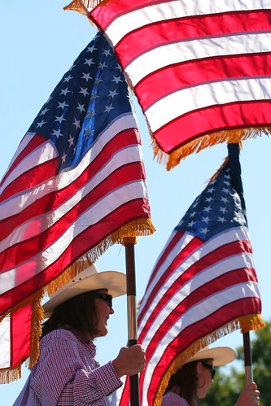
July 2023 Newsletter
Our monthly newsletter includes updates from the Board, recognizes renewing and new members, shares upcoming events, photo gallery and more.

BUSINESS Over BREAKFAST
Coffee- Contacts- Partnerships
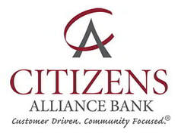
Latest trends in the banking/lending world. Presented by Brad Peterson

Tuesday, July 11th, 2023
7:30 am. Light Breakfast, 8 am. Program
Pioneer PBS Conference room
RSVP 320-321-3202 or granitefallschamberofcommerce@gmail.com
Chamber Business Members: Free, Individual Chamber Members: $5.00, Friends: $10.00
Monthly Business Over Breakfast is sponsored by: Almich’s Market, Citizen’s Alliance Bank; Granite Falls, FM BANK; Granite Falls, Pioneer PBS, Prairie’s Edge Casino Resort, and YME Schools.

Upcoming Member Events:
Every Evening – Fresh Hot Buttered Popcorn and 1919 Root Beer – Granite Falls Kiwanis Popcorn Stand.
Every Thursday- Knockout Tacos & $1 off Margaritas- The Rock: Dining & Events
Every Thursday- Bingo 7 pm- American Legion
Every Thursday- Burger Day- Granite Run Golf Course
Every Tuesday- Family Storytime at 10 am. June 6 – August 1st.
Second Monday of the Month- Book Club 7 pm @ KCC
City Council Meetings 7 pm. Every First & Third Monday at the City Hall
EDA meetings 5:30 pm. Second Monday at the City Hall
YME School Board meetings 6 pm. Second Monday at YME Board Room

July
3rd- City Council meeting 7 pm @ City Hall
3rd- Fireworks @ Prairie’s Edge Casino Resort
4th- Independence Day
5th- National Bikini Day
6th- Roll In at American Legion 5-8 pm
10th- A Matter of Balance Class Series- GF Living at Home Block Nurse Program 320-564-3235
10th- EDA Board meeting 5:30 pm @ City Hall
11th- Business Over Breakfast- Citizens Alliance Bank @ Pioneer PBS
14th- Avera Granite Falls Ambulance FUND- Day Golf Tournament @ Granite Run
14 & 15- Flea Market @ Prairie Mercantile
16th- National Ice Cream Day
17th- City Council meeting 7 pm @ City Hall
20th- National Hot Dog Day
20th- Roll in at the American Legion 5-8 pm
20th- Diamond Rio Concert 8 pm @ Prairie’s Edge Casino Resort

August
3rd- Roll In @ AmericnLegion 5-8 pm
8th- Business Over Breakfast- CelticCross Massage @ Pioneer PBS conference room
8th- Dino Man by the GF Library 10 am @ KCC
10th- Business After Hours @ Betsy Lavin Interior Design building 5:30- 7pm
11 & 12th- Flea Market @ Prairie Mercantile Antique Store
17th- Roll In @ American Legion 5-8 pm
26th- Rock Fest- The Rock: Dining & Events
31st- Roll In @ American Legion 5-8 pm

Are you a member of the Chamber and have an upcoming event that you would like listed in our monthly newsletter? Feel free to e-mail Bonnie at the Chamber

Business of the Month
Restoring Wellness
Who are your customers? What do you offer/benefits?
Anyone who is looking for a different approach to health and wellness. At Restoring Wellness, we work with your body and help it heal. I focus on digestive health, which contains 70-80% of your immune system. This includes stress management/relief through natural/herbal supplementation, and lifestyle choices that may be helpful to alleviate the individual’s challenges. I also offer 3- and 6-month programs for people who would like someone to hold them accountable and gently guide them as they work to implement new habits.
What is something unique or different that you offer that sets you apart?
When a client comes to see me, we focus on finding the root cause and how it may be alleviated. We do not mask it or cover it up, but work on finding what the body needs to heal. People also find that when they come to see me, they have time to talk about their journey and what they are experiencing. This may be physical, emotional and/or spiritual, and it’s all important! I am wholistic in my approach, meaning that I look at all 3 of these areas to help the whole person.
Vision/mission statement
“Helping you create your healthy lifestyle” (byline)
As a Naturopath, Digestive Health Professional, Certified Natural Health Professional and Health Coach, and most importantly, a follower of Yeshua (Jesus), my desire is to help people of all ages with restoring their bodies back to homeostasis, or a state of balance. My passion is to help people on their journey to living the most abundant life possible!
Why are you located in Granite Falls?
I have felt led to come to Granite Falls for a few years. It finally seemed like the right time, and everything fell into place. I have found it to be a welcoming and friendly atmosphere.
Tell us something we don’t know about your business…
I started out as a Certified Health Coach, with my first office being in Montevideo at the “white house” which was owned by LouAnn Kling at the time. After she sold the building in 2017, I moved to Cornerstone Chiropractic.
What is your favorite place in Granite Falls?
Anyplace along the river! It’s beautiful and relaxing.
What are your successes/ Challenges?
My successes are my clients’ successes. When I see their health improving in drastic ways, it is always a blessing. A couple of the biggest personal stories have been a woman who reduced her glucose levels through dietary changes, incorporating light exercise, and enzyme supplements. Another young woman used enzyme therapy along with intense juicing, reducing stressors, and infrared sauna to heal her body of cancer. Other successes are those who notice a difference in how they feel overall, including more energy, sleeping better, improved digestion, less pain, and better moods.

One of the biggest challenges is getting the word out to people that there is another way, and that they can be empowered to take control of their health. We’ve been given this idea that we are victims of our circumstances or genes, but there is much we can do to overcome if we have the knowledge and determination to do so.

Business of the Month 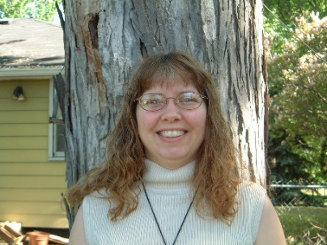
CelticCross Massage

Who are your customers? What do you offer/benefits?
Anyone who is dealing with Chronic Pain – Stress – Anxiety
Anyone who is looking to improve their health – both physical and emotional

What is something unique or different that you offer that sets you apart?
I approach massage from a physical, emotional, and spiritual level – through a variety of massage techniques and essential oils. I also teach self-care techniques to extend the benefits of massage sessions.

Vision/mission statement
My mission is to help improve my client’s physical health through massage and aromatherapy.

Why are you located in Granite Falls?
I recently moved to Montevideo and was looking for a warm friendly place for my business. I love this town... the river and the businesses and the active community.

Tell us something we don’t know about your business…
I sell Young Living essential oils – I also promote the use of essential oils as a way to improve your health by reducing the use of toxic chemicals in everyday products.

I am also a bookkeeper – I have worked with small businesses, especially sole proprietors and new businesses – I love encouraging people to achieve their dreams.

What is your favorite place in Granite Falls?
The river and Dairy Queen!!

What are your successes/ Challenges?
My recent success is the new logo and business cards.
My challenges is as the new kid on the block – to build a client base in an industry that is mostly word of mouth.
Save the Date: September 14th- Ben Bailey at Prairie’s Edge Casino Resort

Save the Date: Business After Hours- Thursday, August 10th- Open House at Betsy Lavin Interior Design building

Thank you to all who participated in the Hula Hoop Contest during the Western Fest Kickoff night, downtown Granite Falls.
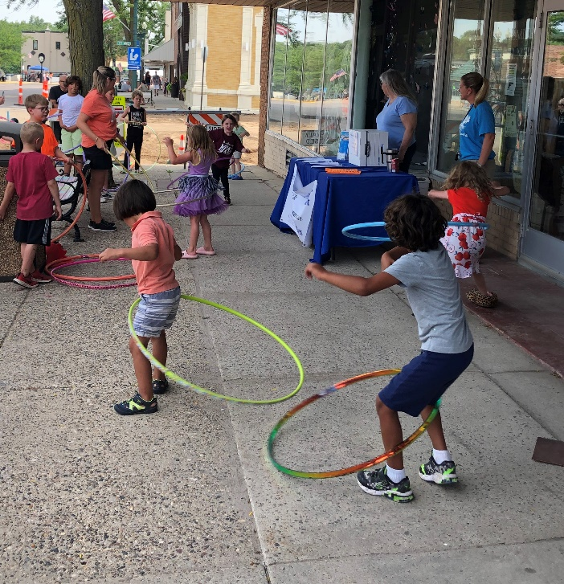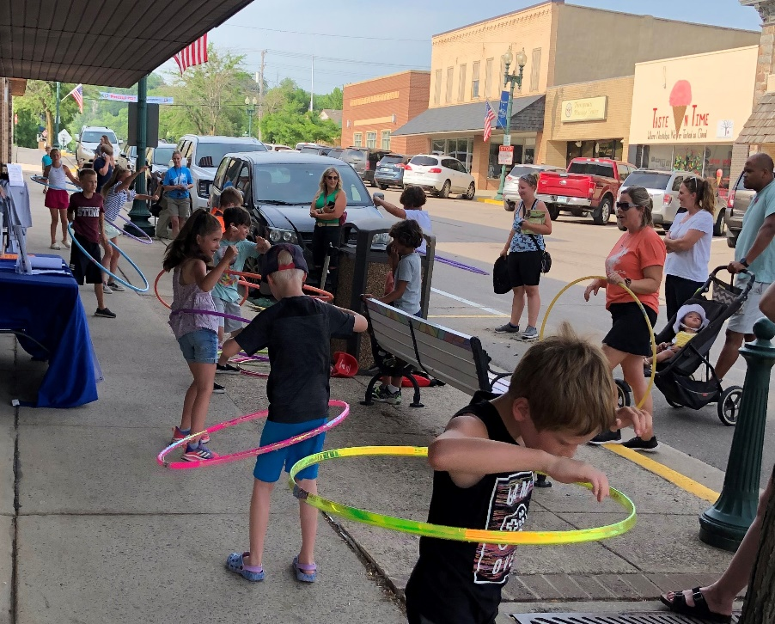
All participants received a FREE Small Ice Cream Cone certificate, provided by Taste in Time & Granite Falls Dairy Queen. Hula Hoop Contest was sponsored by: Citizens Alliance Bank, FM BANK, & Pioneer PBS.

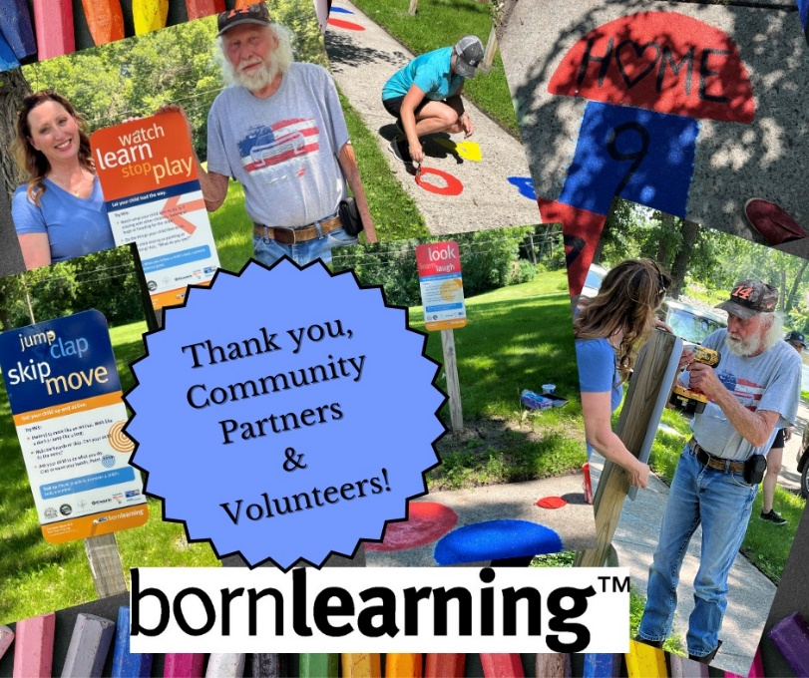

Check out the new “Born Learning Trail” signs at Rice Park.

Brought to you by United Way of Southwest Minnesota

Kiwanis Popcorn Stand 7- 9:30 pm Daily
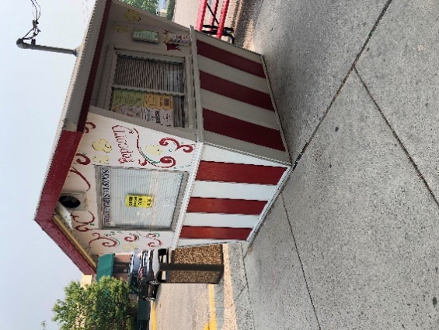

Granite Falls Living at Home Block Nurse Program adds new staff member, Lori Stevens!
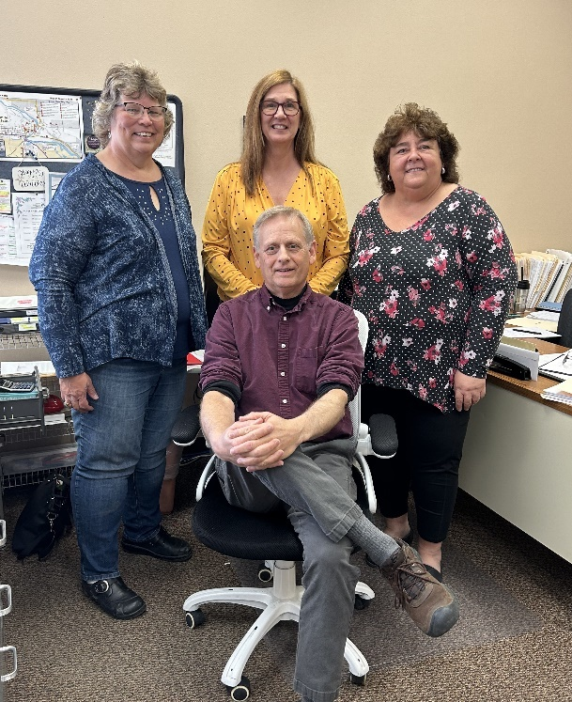
Pictured: Front row: Mark Roisen. Back row L – R: Kelly Van Klompenburg, Lori Stevens, Kim Kranitz-Savig
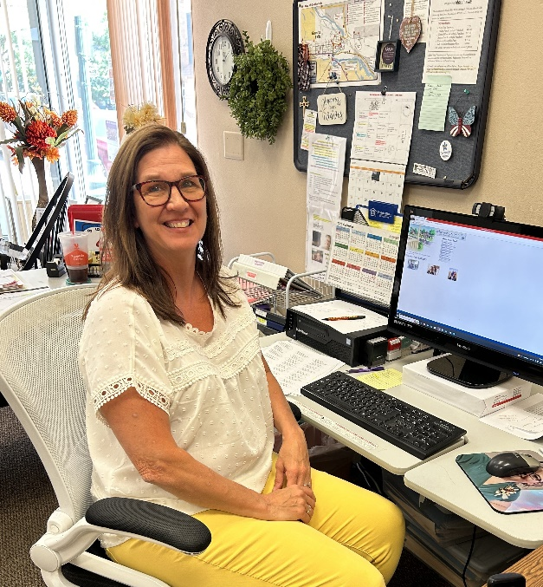Lori Stevens
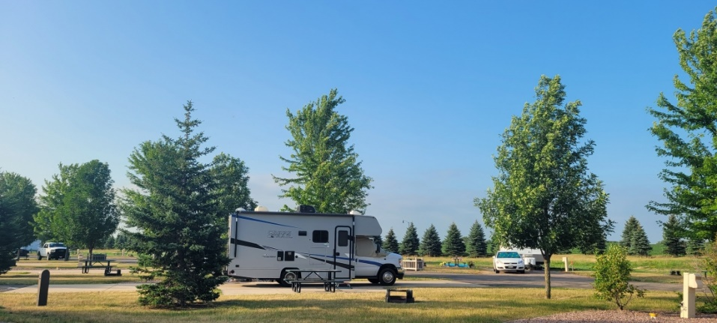
Prairie’s Edge Casino Resort & RV Park and Granite Falls Memorial Park Campgrounds are now open!

June Business Over Breakfast
Thank you, Lynette Ray, Prearrangement Specialist at Anderson-TeBeest Funeral Home for the wonderful presentation at the June Business Over Breakfast.
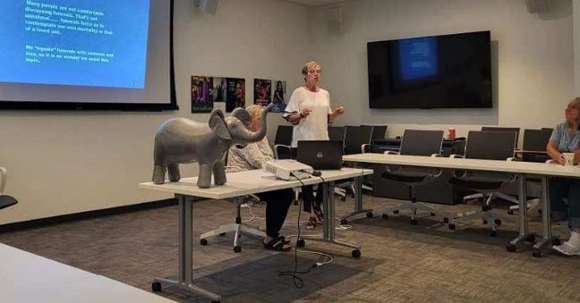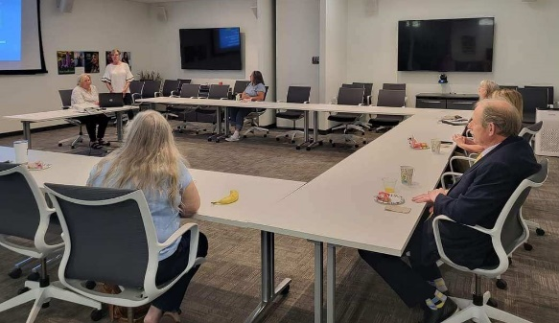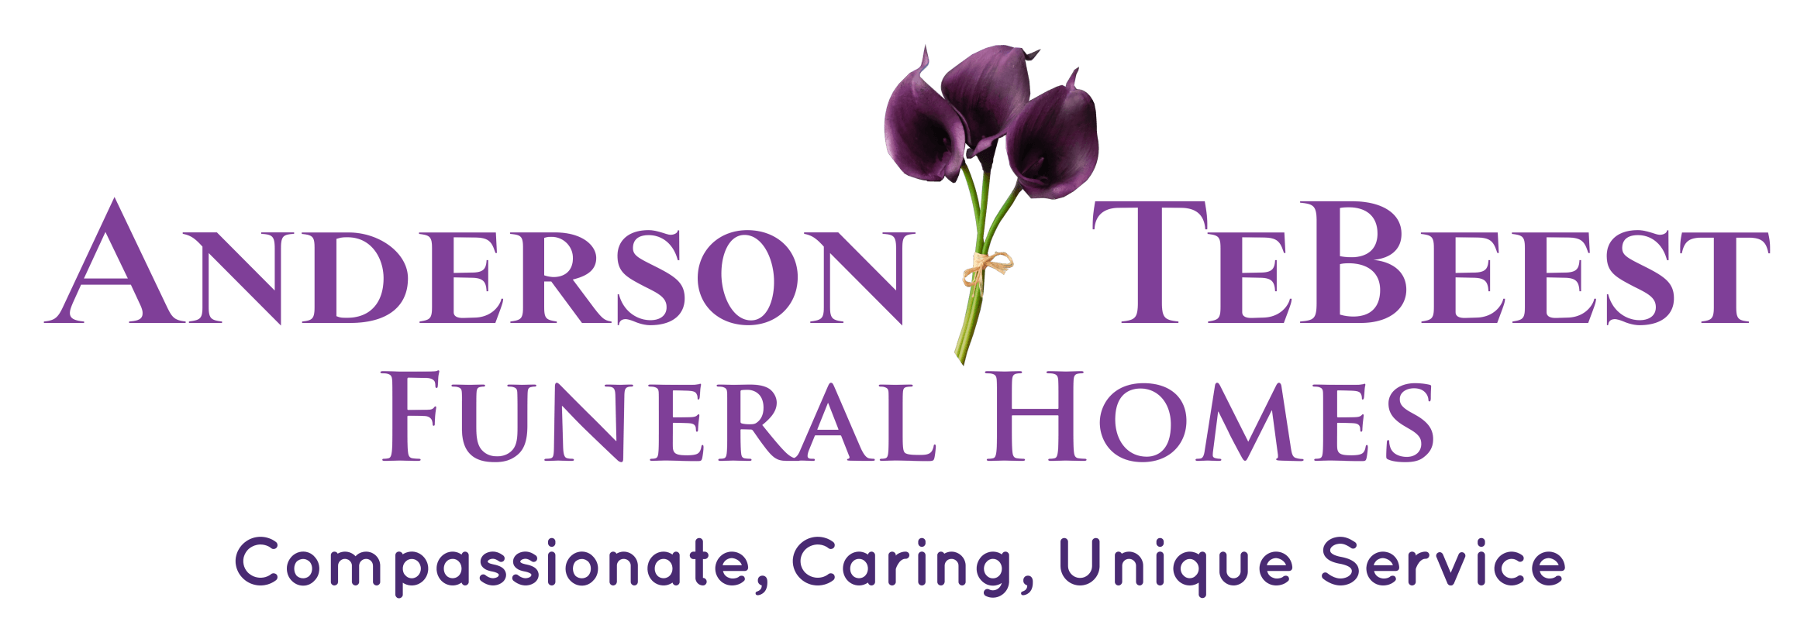

Stuff the Bus
The Granite Falls Chamber of Commerce will be a drop off point for United Way of Southwest Minnesota for collecting new school supplies to help local students start the school year off right!
Learn more at UnitedWaySWMN.org/STB

Update on June’s website analytics and Facebook information… In the month of June, our website, Granitefallschamber.com has had increased activity, with the Top 5 pages viewed being: Western Fest Kick off, Events, Member Directory, Contact Us, and Newsletters. On Facebook, we reached the most people with the following post: “Congratulations and Thank you for all the participants of the Granite Falls Area Chamber of Commerce’s Hula Hoop Contest during the Wester Fest Kick-off last night in downtown Granite Falls. It was fun!” We have 1,507 followers, with 26.7% male, and 73.3% female. Our audience is mostly Granite Falls, with Montevideo, and Marshall area in the running. 212 followers on Instagram. Follow our Facebook page for up-to-date information and events.

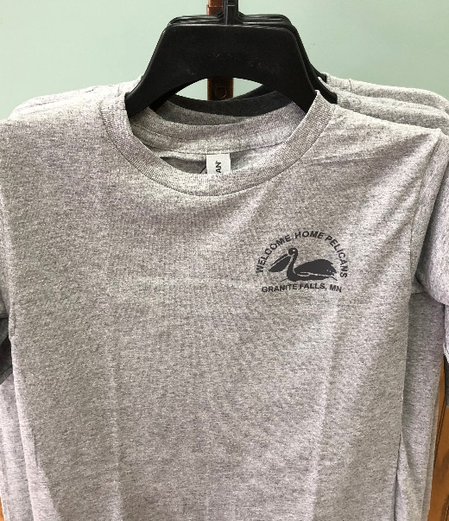
New Pelican Granite Falls Chamber T-shirts are for sale at the Chamber office & at Thrifty White Drug Store

Granite Falls Area Chamber of Commerce Board
Acting President: Carolyn Lindquist, Heather’s Book Nook & SEW Much More
Treasurer: Alicia Beck, Country Financial
Secretary: Pam Rosenau, MVTV Wireless Internet
Director: Kevin TeBeest, Anderson-TeBeest Funeral Home
Director: Kelly Kruger, Scenic Valley Real Estate
Executive Director: Bonnie Vik

Lobby Hours: Monday- Friday 9 am- 5:30 pm.
Office Hours: Monday- Friday 10 am – 2pm.
Granite Falls Chamber of Commerce
676 Prentice Street
Granite Falls, MN 56241
Email: granitefallschamberofcommerce@gmail.com
www.granitefallschamber.com
320-321-3202

